**Name: Anish Ashok Sharma Sap id: 60003220045**

**Branch: Information Technology Div: D/IT1**

**Course**: **Object Oriented Programming using Java**

# Experiment no. 5

Aim: To implement class with members and methods (static, non-static, recursive and overloaded methods)

**Problem Statement 1:**

WAP to find value of y using recursive function, where y=x^n

Code:

import java.util.*;

class Power

{

public static int recursion(int b,int pow)

{

if(pow==0)

return 1;

else{

return b*recursion(b,pow-1);

}

}

public static void main(String args[])

{

Scanner obj=new Scanner(System.in);

System.out.println("Enter base and power:");

int base=obj.nextInt();

int pow=obj.nextInt();

int ans=recursion(base,pow);

System.out.println("Power:"+ans);

}

}

Output

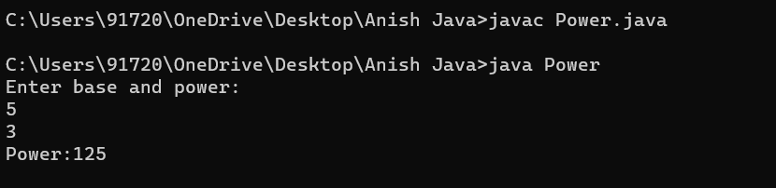

**Problem Statement 2:**

WAP to display area of square and rectangle using the concept of overloaded functions.

Code:

import java.util.*;

class Area

{

int rectArea(int x,int y)

{

return x*y;

}

double rectArea(double x,double y)

{

return x*y;

}

double sqaArea(double x)

{

return x*x;

}

int sqaArea(int x)

{

return x*x;

}

}

public class AreaRS

{

public static void main(String[] args)

{

Scanner obj=new Scanner(System.in);

int area1,area2;

Area obj1=new Area();

System.out.println("Enter length and width");

int len=obj.nextInt();

int wid=obj.nextInt();

area1=obj1.rectArea(len,wid);

System.out.println("Enter side of sqaure");

int side=obj.nextInt();

area2=obj1.sqaArea(side);

System.out.println("Area of rectangle is"+area1+" and Square is "+area2);

}

}

Output

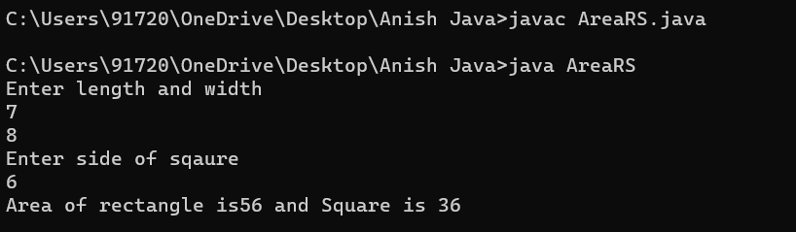

**Problem Statement 3:**

WAP to perform mathematical operations on 2 complex numbers by passing and returning object as argument.

Code :

import java.util.*;

public class Complex {

double real;

double imag;

public Complex(double real, double imag) {

this.real = real;

this.imag = imag;

}

public static void main(String[] args) {

Scanner obj=new Scanner(System.in);

System.out.println("Enter real and imag part:");

double r1=obj.nextDouble();

double i1=obj.nextDouble();

Complex n1 = new Complex(r1, i1);

System.out.println("Enter real and imag part:");

double r2=obj.nextDouble();

double i2=obj.nextDouble();

Complex n2 = new Complex(r2, i2);

Complex temp;

temp = add(n1, n2);

System.out.printf("Sum = %.1f + %.1fi", temp.real, temp.imag);

}

public static Complex add(Complex n1, Complex n2)

{

Complex temp = new Complex(0.0, 0.0);

temp.real = n1.real + n2.real;

temp.imag = n1.imag + n2.imag;

return temp;

}

}

Output

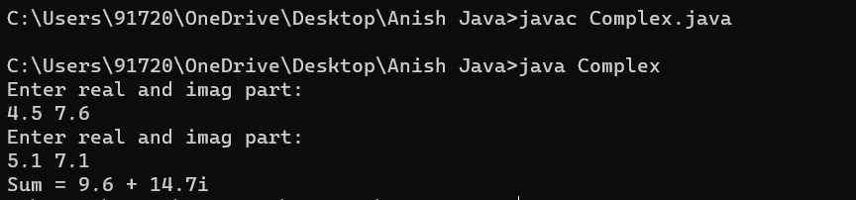

**Problem Statement 4:**

WAP to count the number of objects made of a particular class using static variable and static method to display the same.

Code:

public class ObjectCount1

{

static int count=0;

public static void count()

{

count++;

}

public static void main(String args[])

{

ObjectCount1 c1=new ObjectCount1();

c1.count();

ObjectCount1 c2=new ObjectCount1();

c2.count();

ObjectCount1 c3=new ObjectCount1();

c3.count();

System.out.println("Total Number of Objects: "+count);

}

}

Output

